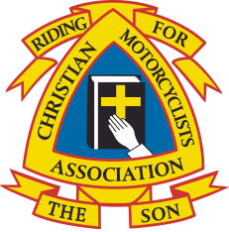
STANDING ORDER FORM
Christian Motorcyclists Association (UK) Ladies
Registered Charity Number: 1080911

To: ………………………………………………………………………………………. (Your bank’s name)
………………………………………………………………………………………….… (Your bank’s address)
…………………………………………………………………………………………….
……………………………………………………………………………………………. (Your bank’s postcode)

From: …………………………………………………………………………………. (Your name)
………………………………………………………………………………………….… (Your account name)
……………………………………………………………………………………………. (Your account number)
……………………………………………………………………………………………. (Your sort code)
……………………………………………………………………………………………. (Customers reference*)
*(Please USE YOUR NAME AS THIS REFERENCE).

INSTRUCTIONS TO THE BANK: Please include the customer’s reference number in all transactions. Thank you.

I/We wish to pay a Standing Order to CMA (UK) Ladies as follows:

Account name: CMA (UK) Ladies
Account number: 50627848
Sort Code: 53-50-15
Bank: NatWest, 13 Market Place, Guisborough, Cleveland, TS14 6BW

1 year plan
12 monthly payments of £12.50
First payment date
Final payment date
Total payment of £150

Personal plan
…… monthly payments of £………….
First payment date
Final payment date
Total payment of £150

Please note: payment of a total of £150 must be paid in full on or before the 1st October 2019. Thank you.

Signed: ……………………………………………………………………………………..

Print Name: ……………………………………………………………………………..

Date: ………………………………………………………………………………………..

